**More Trees for a Cooler, Greener West**

**Report for** *<insert school name>*

In ***<insert month>***2023 our school was involved in the More Trees for a Cooler Greener West program. We planted ***<insert number of trees>*** locally indigenous seedlings. These seedlings will grow into trees and shrubs that will help keep our school and our community cooler, combating the [urban heat island effect](https://www.planning.vic.gov.au/guides-and-resources/data-and-insights/cooling-and-greening-melbourne-map) as Climate Change continues. They will also provide habitat for local birds and insects, spaces for students to play and opportunities for students and staff to connect with nature, which has benefits for wellbeing.

**THIS IS OUR REPORT ON OUR INVOLVEMENT IN THIS PROGRAM.**

We worked with Environment Education Victoria to receive resources and plants for this program and part of a funded project from the Department of Energy, Environment and Climate Action. We received tree seedlings, tree guards and stakes, and support to plan our planting day.

We also collaborated by ***<insert the support received: borrowing tools / using online resources from EEV’s website to teach our students and communicate with our school community / received mulch / had a visit from the Minister to our school>***

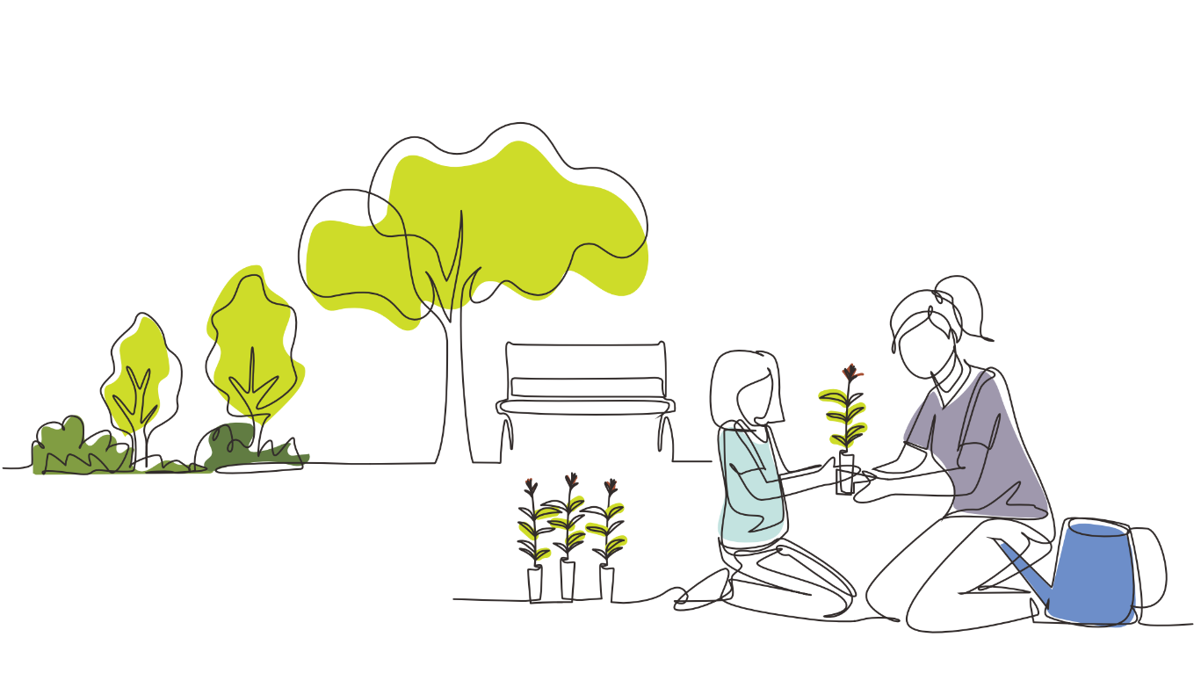

RSS ACTIONS COMPLETED:

* Biodiversity C3.5 (Support received for biodiversity related projects)
* Biodiversity C3.1 (Collaborating with stakeholders)
* Biodiversity A2.3 (Biodiversity improvement grants, awards, or competitions)







**PLANTING TREES AND SHRUBS AT OUR SCHOOL**

We prepared our site by ***<insert actions undertaken to supress/remove weeds e.g. using newspaper / cardboard /wood chip mulch, we had staff spray for weeds, we hand weeded the site>.***

RSS ACTIONS COMPLETED:

* Biodiversity A4.1 (Mulching, weed control and vegetation litter management)

Planting at our school took place on ***<insert day or days as dates>. <insert number of students>***students were involved in planting the seedlings from year levels ***<insert year levels>.*** *Seedlings were planted, watered in and protected with tree guards and stakes.*

RSS ACTIONS COMPLETED:

* Biodiversity A3.3 (Habitat development)
* Biodiversity A3.4 (Protection for sensitive vegetation)
* Biodiversity B1.3 (Hands on, authentic learning opportunities)

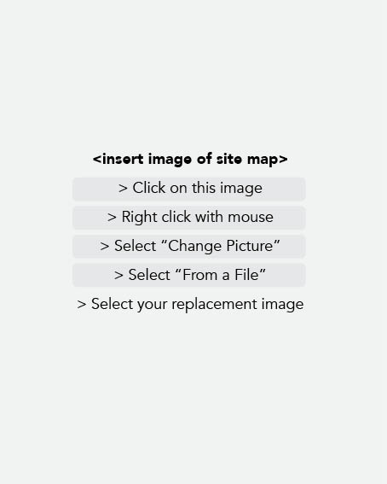**<INSERT SCHOOL NAME>** **SITE MAP**

This plan shows the planting locations, and monitoring sites including photo points to monitor the growth of seedlings over time, and sites where we will monitor temperatures to track changes as the trees grow.

**PLANTING DAY**

|  |  |  |
| --- | --- | --- |
|  |  | |
|  | |  |
|  |  | |

These photos show our progress and the transformation of our school grounds.

**THESE ARE THE SPECIES WE PLANTED AT OUR SCHOOL**

|  |  |  |
| --- | --- | --- |
| **LOWER SPECIES SHRUBS** | **Yes** | **No** |
| Gold Dust Wattle - *Acacia acinacea* | • | • |
| Hedge Wattle - *Acacia paradoxa* | • | • |
| Prickly Moses  - *Acacia verticiliata* | • | • |
| Sweet Bursaria - *Bursaria spinosa* | • | • |
| Bottlebrush - *Callistemon sieberi* | • | • |
| Hop Bush - *Dodonea viscosa* | • | • |
| Australian Indigo - *Indigofera australis* | • | • |
| Black Paperbark - *Melaleuca lanceolata* | • | • |
| Tree Violet - *Melicytus dentatus* | • | • |
| **MID-STOREY TREES** | **Yes** | **No** |
| Lightwood - *Acacia implexa* | • | • |
| Black Sheoak - *Allocasuarina littoralis* | • | • |
| Buloke - *Allocasuarina leuhmannii* | • | • |
| Drooping Sheoak - *Allocasuarina verticilata* | • | • |
| **UPPER-STOREY TREES** | **Yes** | **No** |
| Silver Wattle - *Acacia dealbata* | • | • |
| Blackwood - *Acacia melanoxylon* | • | • |
| River Red Gum - *Eucalyptus camaldulensis* | • | • |
| Yellow Gum *- Eucalyptus leucoxylon* | • | • |
| Yellow Box - *Eucalyptus melliodora* | • | • |
| Swamp Gum - *Eucalyptus ovata* | • | • |
| Manna Gum *- Eucalyptus viminalis* | • | • |

Indicated above are the species that we planted at our school. ***<delete indicator dots as appropriate>***

If you require further information, please check out the [DEECA Seedlings List](https://www.eev.vic.edu.au/more-trees-seedling-images-1) which includes a full image gallery.

**CURRICULUM AND CLASSROOM LEARNING**

Our students learned about ***<trees/climate change/local habitat/other>*** in the classroom.   
***<Teacher to insert brief description about work undertaken – include which year levels, subject   
and curriculum connections, description of activity and learnings>.***

RSS ACTIONS COMPLETED:

* Biodiversity B1.1 (Education activities linked to Biodiversity)
* Biodiversity B1.2 (Biodiversity education linked to mandated curriculum) * (Delete if not applicable)

|  |  |
| --- | --- |
|  | |
|  |  |

**COMMUNITY INVOLVEMENT** * (Delete section if not applicable)

We shared information with our school community about the planting day through our  ***<insert method of communication: eg. newsletters / website / class communications / other>***

|  |  |
| --- | --- |
|  | |
|  |  |

**COMMUNITY INVOLVEMENT**

***<insert number of parents involved>*** helped us with the project. The help we received from parents included ***<planting seedlings, spreading mulch, donating cardboard for weed management, donating materials, assisting with classroom activities, other – type description>***

RSS ACTIONS COMPLETED:

* Biodiversity C1.1 (Shared activities with community - Compulsory)

|  |  |
| --- | --- |
|  | |
|  |  |

**SUMMARY**

SUMMARY OF RSS ACTIONS COMPLETED THROUGH THE MORE TREES PROJECT:

* Biodiversity A2.3 (Biodiversity improvement grants, awards or competitions)
* Biodiversity A4.1 (Mulching, weed control and vegetation litter management)
* Biodiversity B1.1 (Education activities linked to Biodiversity)
* Biodiversity B1.2 (Biodiversity education linked to mandated curriculum)
* Biodiversity C1.1 (Shared activities with community - Compulsory)
* Biodiversity C3.1 (Collaborating with stakeholders)
* Biodiversity C3.5 (Support received for biodiversity related projects)